AUTOMATED LIBRARY SYSTEM FOR ENCHANCED RESOURCES ACCESSIBILITY

A PROJECT PRESENTED TO THE FACULTY OF URDANETA CITY UNIVERSITY COMPUTER ENGINEERING

IN PARTIAL FULFILLMENT OF THE REQUIREMENTS FOR THE SUBJECT DATA STRUCTURE AND ALGORITHMS LABORATORY

GROUP 1:
MARK JETHRO T. VALDEZ
ALFE JAN ANDRIE U. AGULAN
FHENELYN ROSE A. YADAO
CHARLIZE KATE B. LACAMBRA
KURT CEDRIC D. CAPULI
ALEXANDER NOEL D. ABANDO
CHAPTER 1
Background of the project
A primary objective of automated library system is to design and execute a productive and user-friendly framework that mechanizes the different tasks related with managing a library. Automated Library System is a software application that simplifies and automates library operations. Automated Library System that allows users to manage book information. Users can add books, display all books, list books by a specific author, count the total number of books, and remove books from the library. The advantage of automated library system to people is that it makes information more available and accessible in an easier manner. Its main purpose is to help manage books in a small library.
Objective of the project
The primary goals of the project include:
1. To determine the advantages of automated library system
2. To make it easy to Barrow, display, or Return books
3. To have efficient book management.

Scope and Limitation
The project is a simple library management system designed to allow students to create accounts, log in, and borrow books.
The scope of this project library management system typically focused on the following aspects: Account Management that students can create accounts by entering their names, student ID numbers, and passwords, Login System that students can log in using their ID numbers and passwords, and lastly Book Borrowing that students can view the list of available books and borrow one book at a time. The system ensures that borrowed books are marked as unavailable.
This project limited to managing a maximum of 100 books, lacks advanced error handling for invalid inputs, does not save data permanently (losing all information upon closure), does not include advanced features such as returning books or adding new books, and does not include features like sorting, advanced searches, or book categorization.

CHAPTER 2
Code Purpose
The Library Management System is a program that provides the facility for user registration and login so that the authenticated user can handle a virtual collection of books. The following operations are supported by the program:
1. Creating a user account.
2. Verifying user login.
4. Displaying all the books.
6. Total number of books.
Header Files and Macros
- stdio.h : Contains input/output functions - printf and scanf.
- stdlib.h : Contains system utilities like exit().
- string.h : Contains string functions like strcmp and strcpy
- Macros MaxUser and MaxBooks are used for maximum limits of users and books available in the system.

Main Functionality
The core functionality of the program involves two primary operational modes: the "Pre-login Phase" and the "Post-login Phase". In each phase, specific tasks need to be executed with a high efficiency. The "Pre-login Phase" focuses on user authentication and access control, thus ensuring that those who have proper authorization can proceed ahead in the system. This phase is in charge of the account creation for new users and secure login for the returning ones. In contrast, the "Post-login Phase" is oriented towards library management and allows users to perform a variety of activities related to the administration of book records. Together, these phases create a systematic approach to the secure and efficient management of the library system.
Pre-Login Phase
This phase ensures there is secure access to the library management system because only people who are registered can use it. There are primarily two functionalities: account creation, which registers new users safely by storing their credentials, and logging in, which verifies all the user's credentials before authenticating and granting one access.
Account Creation
Purpose: The account creation functionality allows new users to register by securely storing their credentials for future access.
Login
Purpose: The login feature checks the entered user credentials against the stored data to ensure that only authorized individuals can access the system, thereby safeguarding its functionality from unauthorized use.
Post-Login Phase
After successful login, users are granted access to the core functionalities of the library management system. In this phase, the stored book information in the "lib" array is managed; adding, viewing, searching for, and deleting book information.
Adding Book Information
Purpose: This feature enables the users to increase the library's collection by introducing new books. Purpose: Users can input information regarding the book, which then gets stored in the library database for easy management and future reference.
Display Book Information
Purpose: This feature gives a complete view of all books stored in the library. The users can easily access and review the details of each book currently available in the collection.
Listing Books by Author
Purpose: This feature enables users to search the library's collection for books written by a specific author, making it easier to locate and view relevant titles from the database.
Counting Total Books
Purpose: This feature calculates and displays the total number of books currently stored in the library, providing users with an overview of the library’s overall inventory size.

Removing a Book
Purpose: This is the function that permits deleting a certain book of a library with the user indicating its index. Once such a book is permanently removed from the collection, its deletion affects the database.
Exiting Program
Purpose: This feature terminates the running program safely, ensuring full release of resources and safe closure of the session.
Code Strengths
It will implement basic user authentication that securely manages usernames and passwords, allowing only authorized persons to access the system. This prevents unauthorized access into the library management system while ensuring privacy of user data.
Menu-Driven Design
The program is menu-driven, with clear prompts and easy-to-follow options. This simplifies navigation, making it accessible and user-friendly for both new and experienced users.

Dynamic Book Management
It has dynamic book management, so that it supports adding, viewing, searching, and deleting books, making library management flexible and efficient.
Areas of Improvement
Error handling: It addresses issues such as an invalid choice, buffer overflows, and empty inputs to make sure the system works smoothly without crashes or unexpected behavior.
Permanent Storage
Currently, data is stored only in memory. Thus, it gets lost once the program is closed. File-based storage will be implemented to ensure that user and book data persist between program executions, hence ensuring data continuity.
Additional Features
To enhance book tracking, the library structure can include extra fields, such as publication year or ISBN. Additional sorting options by title or author would make the system more usable and organize.

Code of the Project
#include <stdio.h>
#include <stdlib.h>
#include <string.h>

#define MaxUser 100
#define MaxBooks 100
#define Namelenght 50
#define Passlenght 20

typedef struct {
char name[Namelenght];
int id;
char password[Passlenght];
int borrowedBookIndex;
} User;

typedef struct {
char title[Namelenght];
int isAvailable;
} Book;

User users[MaxUser];
Book books[MaxBooks];
int userCount = 0;
int bookCount = 0;

//Create a account
void createAccount() {
if (userCount >= MaxUser) {
printf("User limit reached.\n");
return;
}
User newUser;
printf("Enter student name: ");
fgets(newUser.name, Namelenght, stdin);
newUser.name[strcspn(newUser.name, "\n")] = 0;
printf("Enter student ID number: ");
scanf("%d", &newUser.id);
getchar();
printf("Enter password: ");
fgets(newUser.password, Passlenght, stdin);
newUser.password[strcspn(newUser.password, "\n")] = 0;
newUser.borrowedBookIndex = -1;
users[userCount++] = newUser;
printf("Account created successfully.\n");
}
//Login process
int login() {
int userId;
char password[Passlenght];
printf("Enter student ID number: ");
scanf("%d", &userId);
getchar();
printf("Enter password: ");
fgets(password, Passlenght, stdin);
password[strcspn(password, "\n")] = 0;

for (int i = 0; i < userCount; i++) {
if (users[i].id == userId && strcmp(users[i].password, password) == 0) {
return i;
}
}
printf("Invalid login credentials.\n");
return -1;
}

void borrowBook(int userIndex) {
int availableBooksCount = 0;
for (int i = 0; i < bookCount; i++) {
if (books[i].isAvailable) {
availableBooksCount++;
}
}
if (availableBooksCount == 0) {
printf("No books available to borrow.\n");
return;
}
printf("Available books:\n");
for (int i = 0; i < bookCount; i++) {
if (books[i].isAvailable) {
printf("%d: %s\n", i + 1, books[i].title);
}
}
int bookChoice;
printf("Select a book to borrow (1-%d): ", availableBooksCount);
scanf("%d", &bookChoice);
if (bookChoice < 1 || bookChoice > bookCount || !books[bookChoice - 1].isAvailable) {
printf("Invalid choice.\n");
return;
}
books[bookChoice - 1].isAvailable = 0;
users[userIndex].borrowedBookIndex = bookChoice - 1;
printf("You have borrowed: %s\n", books[bookChoice - 1].title);
}

void returnBook(int userIndex) {
int borrowedIndex = users[userIndex].borrowedBookIndex;
if (borrowedIndex == -1) {
printf("You have not borrowed any book.\n");
return;
}
books[borrowedIndex].isAvailable = 1;
printf("You have returned: %s\n", books[borrowedIndex].title);
users[userIndex].borrowedBookIndex = -1;
}

int main() {
// Library books
strcpy(books[0].title, "Data Structures");
books[0].isAvailable = 1;
strcpy(books[1].title, "Don Quixote. Miguel de Cervantes");
books[1].isAvailable = 1;
strcpy(books[2].title, "Alice's Adventures in Wonderland. Lewis Carroll");
books[2].isAvailable = 1;
strcpy(books[3].title, "Wuthering Heights. Emily Brontë");
books[3].isAvailable = 1;
strcpy(books[4].title, "Noli Me Tángere. José Rizal");
books[4].isAvailable = 1;
strcpy(books[5].title, "The Reign of Greed. José Rizal");
books[5].isAvailable = 1;
strcpy(books[6].title, "The Lord of the Rings");
books[6].isAvailable = 1;
strcpy(books[7].title, "The Road: By Cormac McCarthy");
books[7].isAvailable = 1;
strcpy(books[8].title, "Harry Potter and the Chamber of Secrets J. K. Rowling");
books[8].isAvailable = 1;
strcpy(books[9].title, "Harry Potter and the Philosopher's Stone");
books[9].isAvailable = 1;
bookCount = 10;

int choice;
printf("\tLibrary System Management\n");
do {
printf("1. Create Account\n2. Login\n3. Exit\n");
printf("Enter your choice: ");
scanf("%d", &choice);
getchar();

switch (choice) {
case 1:
createAccount();
break;
case 2: {
int userIndex = login();
if (userIndex != -1) {
int actionChoice;
do {
printf("1. Borrow a Book\n2. Return a Book\n3. Logout\n");
printf("Select an action: ");
scanf("%d", &actionChoice);
getchar();
switch (actionChoice) {
case 1:
borrowBook(userIndex);
break;
case 2:
returnBook(userIndex);
break;
case 3:
printf("Logging out...\n");
break;
default:
printf("Invalid choice. Please try again.\n");
}
} while (actionChoice != 3);
}
break;
}
case 3:
printf("Exiting...\n");
break;
default:
printf("Invalid choice. Please try again.\n");
}
} while (choice != 3);

return 0;
}

Purpose of the Flow Chart
The flow chart is a graphical presentation of the Automated Library System's processes. It explains the sequence of tasks and decisions made in the operation of a library, such as registering users, managing books, and storing data. The information presented graphically helps make complex processes easier to understand, making it easier for readers to understand the structure and functionality of the overall system.

Importance of the Flow Chart
The inclusion of the flow chart in this research provides several benefits:
Clarity: It offers a clear and straightforward depiction of the Automated Library System's workflow, thus enhancing the reader's comprehension.
Efficiency: By visualizing the process, it allows for quicker assimilation of information, which is particularly useful for understanding complex systems.
Communication: The flow chart serves as an effective communication tool, helping to bridge the gap between technical details and conceptual understanding.

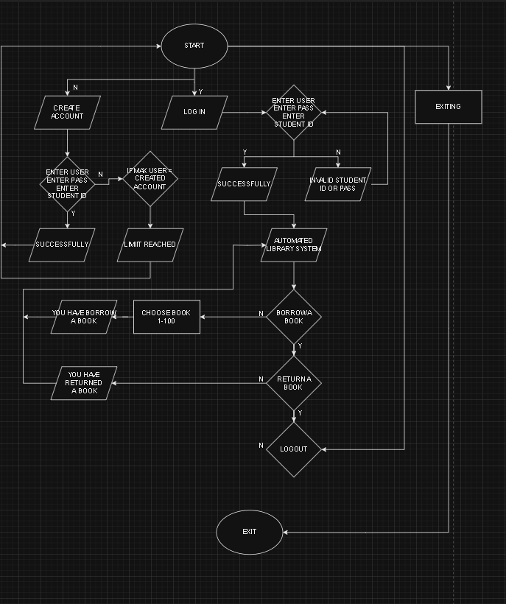

CHAPTER 3
Conclusion and Recommendation
Conclusion
The Automated Library System project successfully addresses the need for one of the most user-friendly foundations to speed up a library's operations. By automating tasks such as adding, displaying, searching, and removing books, the system can facilitate the operation of a library. The user-friendly interface ensures ease of use for all users, regardless of their background. Moreover, secure user management enhances the protection of their sensitive information, with only authorized individuals allowed to access the system very easily and they will not face any difficulties.
However, some areas for improvement were identified. The current system is limited to managing a maximum of 100 books and lacks advanced error handling and persistent storage, which are essential for data continuity and reliability. By addressing these limitations, the system can be made lighter and faster and practical for larger libraries.

Recommendation
The researcher makes the following recommendations for the Automated Library System for Enhanced Resources Accessibility:
1. Future researchers should look at redesigning the system for support of many more books. Dynamic data structures like linked lists or even the transition to database solutions can better handle larger libraries without performance degradations.
2. Future researchers should emphasize the security features of the library system. This includes using encryption for the user data, multi-factor authentication while logging in, and protocols on backing up data to avoid leakage of sensitive information and security vulnerabilities.
3.The availability of a real-time book reservation system can be added such that users can reserve checked-out books. Features in the system can notify a user when the book becomes available, ensuring proper allocation of resources.
4.It is possible to track user activity trends, book borrowing, and the usage of a book with data analytics, thus aiding library administrators to make appropriate decisions about book acquisition, circulation of books, and identifying those which are either underutilized or highly demanded.
5.Enhance the error-handling capability of the system to handle unexpected inputs, boundary cases, and system failures. For instance, implement input validation for invalid entries, checks for null or empty fields, and error messages to guide users effectively.
6. Future versions of the system could be integrated with other external library networks or digital repositories. This would give users access to books in other libraries, making the system a hub for a larger collection of resources.

